Teaching Case/Instructor Materials
Blank line here
Title – Template for
Instructor Materials
18 point Verdana

Leave Space for Author Info
Leave out Authors for Initial Consideration Submission
for Journal or Conference
Insert Author Information Once Accepted
12 point headings For Hook & Abstract

Hook

“Hook” statement that generates interest in the case. Think of this like a phrase that you might see on a poster advertising a motion picture
9 point Verdana
this point forward
Abstract

The abstract should summarize the content of the paper. Make it a single paragraph. Try to keep it below 250 words and do not include equations or references in it. If you use abbreviations in the paper, i.e., CIS, use the full meaning of the abbreviation in the abstract or at first use, i.e., Computer Information Systems.

Keywords: Select four to six keywords that capture the essence of the paper. List the words in decreasing order of importance from left to right, with commas between the key word concepts.
Columns: 3.1”, with 0.3 between

1. IMPORTANT INFORMATION

The appearance of the Conference proceedings and the ISCAP journals are greatly enhanced by standardized formatting. Formatting is the same for both Conference and Journal submissions. This template is needed only for Conference submission, as you’ll be asked to make updates to your final Conference proceedings paper (returned to you with the Journal invite) for the Journal review.

The only format accepted will be Microsoft Word documents. Please submit in .docx format (if your file is extremely large, please prepare the document in Word and then Zip the file).

For initial submission, please remove personal identifying information from document content and metadata. To remove Word metadata:
File > Info > Check for Issues > Inspect Document >Document Inspector > Document Properties and Personal Information.

Page Layout Options
The entire document layout (every page) should be set to 1.0 top margin, 1.0 bottom margin, 1.0 left margin, and 1.0 right margin. After the keywords, insert a section break (use - Breaks) - continuous and format column to two (3.1 inch) with spacing of 0.3 inches between columns. While on the Page Layout Tab, change the Hyphenation Option to NONE.

In addition, please set your pages to full justification. Do not use any headers, footers, page numbers or footnotes in your document. If you have any headers/footers, please delete all as they will interfere with the conference information we will place there when published to the web.

Set the font to Verdana, if you have it available. Use 9 point font for the body of the paper. If you do not have Verdana use Times New Roman.

Use the paragraph / spacing options to set paragraphs to alignment justified, indent zero, spacing before to 0pt, spacing below zero, and line spacing zero, except for the citation section. Please check your paragraph line spacing as the newer MS templates defaults the line spacing to 1.15, please revise to single.
The font should be Verdana 9 pt. Please put a single blank line between paragraphs. Use a single space at the end of each sentence. Please use a single space after colons.

Title
The title should be Verdana 18pt font, Mixed Case (not UPPER CASE), not bold. You may insert soft returns (shift enter) into long titles to improve readability. Center your title. Because the first page top margin is 1.0 inches, please add a blank line before the title.

Multiple authors: If your paper has multiple authors, your title format will need to be slightly adjusted. The adjustments to be made are slightly different for authors from the same and different universities (Table 1)

University | Author Info | Spacing
Different | Complete info for each | Two 12 pt blank rows between each author
Same | Author name and email for each followed by address | One blank line between each individual author followed by two blank lines and address information
Table 1: How to Handle Multiple Authors for the Paper

Templates of each of these formats can be found in Appendix 1. Because the templates are title page examples, a screen capture illustrating how to refer to an appendix item is provided in Figure 1.

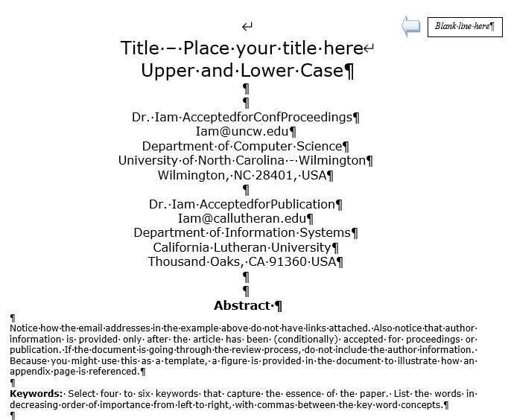
Figure 1 Appendix Item Reference Example

Abstract
The word “Abstract” should be centered in Verdana 12pt bold. The rest of the abstract and the keywords should be Verdana 9pt font. The word “Keywords:” should be bold. The abstract should not exceed 250 words.

Keywords
Select four to seven keywords that capture the essence of the paper. List the words in decreasing order of importance from left to right.

2. PREPARATION OF MANUSCRIPTS

Major section headings should have alignment centered, indent zero, all caps- and bold as shown below.

Please note that paper submissions must be limited to 5000 words (max), excluding appendices and references.

General Appearance
The text of the conference is English. Your paper must not contain corrections nor should they contain page numbers, headers or footers. This document is printed in the format that should be used in the paper.

3. HEADINGS

Major headings are to be column centered, numbered, in a capitalized bold font as shown in this document. Do not use the Microsoft List Item Numbering as it will not center properly.

Subheadings
Subheadings should be in bold font with initial capitals, and left-justified. Insert one line before the subheading title, but not after.

Both major headings and subheadings should be set to “Keep with Next” so that they stay with their content as the paper may be slightly edited.

4. FIGURES/TABLES

Figures and tables should be placed in the manuscript on the page where they are referenced (if they fit). Figures and tables that will not fit in one column should span the entire page and should be located at the top or bottom of the page (see Appendix D). Section breaks should not be used when adding tables/figures. To achieve the proper formatting, format figures and tables with text wrapping (tight) and position the item at the top or bottom of the page.

Place the identify information about tables and figures, below the Figure or Table in bold. Do not use italics. Use a colon to separate the table or figure number from its brief and descriptive caption, and use initial caps for the caption words, as for the title and subheadings.

You also have the option to place large tables and figures in the appendix.

5. FORMULAE

All equations must be typed utilizing a suitable processor. They should be numbered consecutively throughout the text, at the flush-right edge of the equation, enclosed in parentheses. It is acceptable to present equations as .jpg or .gif files, 3.1 inches wide.

6. CONCLUSIONS

The enhancements to information systems education is identified or repeated here. DO NOT repeat the abstract or portions of it.

7. ACKNOWLEDGEMENTS

Place before the references.

8. FOOTNOTES

Use endnotes instead.

9. REFERENCES

We request you follow the APA (American Psychological Association) guidelines to cite sources. Please include Digital Object Identifiers (DOI) links for all references where possible. DOI citations should follow the APA guidelines.
Following are examples of typical citation items:
Ashby, W. Ross (1956). An Introduction to Cybernetics. Methuen Press, London. (Book)
Harris, A. (2009). Publishing in JISE. Journal of Information Systems Educators, 7(1), 12-15. https://doi.org/xxxxx (Journal with 1 Author and DOI reference).
Harris, A., & Harris J. (2010). Publishing in JISE. Journal of Information Systems Educators, 7(1), 12-15. https://doi.org/xxxxx (Journal with 2 Authors)
Harris, A., Harris J., & Colton D. (2011). Publishing in JISE. Journal of Information Systems Educators, 7(1), 12-15. https://doi.org/xxxxx (Journal with 3 or more Authors)
Hunsinger, S. (2010). My life with Word Press. In M. Smith (Ed.), Word Press in the 21st Century . High Point Press. (Book Chapter with Editor)
Sample, P., & Canary, W. (2008). Why Web 2.0 implies I should get a raise. New England Online Education 7(12). Retrieved June 6, 2010 from https://giveaddress.com/xxx (On line Journal or Publication or Article)
White, B. (2009, June 1). Why June is a great month to submit an article to ISCAP. Chronicle of Higher Education, 22(7), 15-16. (Magazine Article)
When citing references in the text, include the last name and year. The citation should appear in parentheses such as (Ashby, 1956) or, if you need to comment about Ashby (1956) stated we are great.
Two author papers should be cited in the document as (Harris & Witman, 2009). Three or more authors in a paper should be cited with the name of the first author and “et al.” in each instance, including the first citation: (Harris et al., 2009). The only exception would be if doing so would create ambiguity.
If two or more papers are cited by the same author, separate the years with commas. Identical years for the same author should appear as (2009a) and (2009b) in the body of the document as well as the references.
If the author of a paper is not provided, alphabetize according to the title of the work. If the first word in the title is a number, alphabetize as if the number were a written word, for example, “10 Best Practices” would be alphabetized as though it were written as the word “ten.”

Appendices and Annexures

Typically, an appendix or annexure will include actual handouts given in class, or questionnaires used for surveys, or other presentation graphics and tables that do not fit readily into the body of the paper but are still important for clarity or completeness. Often these items were prepared for other purposes than presentation as a part of your paper, and it is acceptable that they do not adhere to font face, font size, and column requirements observed elsewhere in your paper.

In appendices, you are allowed to have margins that are larger but not smaller than the generally required margins, which are 1.0 top margin, 1.0 bottom margin, 1.0 left margin, and 1.0 right margin

So long as you adhere to the margin requirements, appendices may be presented in any format that you desire.

Rotated pages (landscape orientation) are not allowed in the body of the document, but they are permitted in the appendices. This will allow the entire page to be rotated anti-clockwise 90 degrees for final typesetting.

Please label each appendix section with a serially lettered heading in all caps/bold, e.g., APPENDIX A. The following line should give title of that appendix section, in mixed case/bold, e.g., Title of Content for this Part of the Appendices.

APPENDIX A
Submission Title Page for Accepted Papers – Two Authors, Different Schools
Title – Place your title here
Upper and Lower Case
Blank line here

Dr. Iam AcceptedforConfProceedings
Iam@uncw.edu
Department of Computer Science
University of North Carolina - Wilmington
Wilmington, NC 28401, USA

Abstract

Notice how the email addresses in the example above do not have links attached. Also notice that author information is provided only after the article has been (conditionally) accepted for proceedings or publication. If the document is going through the review process, do not include the author information. Because you might use this as a template, a figure is provided in the document to illustrate how an appendix page is referenced.

Keywords: Select four to six keywords that capture the essence of the paper. List the words in decreasing order of importance from left to right, with commas between the key word concepts.

APPENDIX B
Submission Title Page for Accepted Papers – Two Authors, Different Schools
Title – Place your title here
Upper and Lower Case
Blank line here

Dr. Iam AcceptedforConfProceedings
Iam@uncw.edu
Department of Computer Science
University of North Carolina - Wilmington
Wilmington, NC 28401, USA

Dr. Iam AcceptedforPublication
Iam@callutheran.edu
Department of Information Systems
California Lutheran University
Thousand Oaks, CA 91360 USA

Abstract

Notice how the email addresses in the example above do not have links attached. Also notice that author information is provided only after the article has been (conditionally) accepted for proceedings or publication. If the document is going through the review process, do not include the author information. Because you might use this as a template, a figure is provided in the document to illustrate how an appendix page is referenced.

Keywords: Select four to six keywords that capture the essence of the paper. List the words in decreasing order of importance from left to right, with commas between the key word concepts.

APPENDIX C
Submission Title Page for Accepted Papers – Two Authors, Same School
Title – Place your title here
Upper and Lower Case
Blank line here

Dr. Iam AcceptedforConfProceedings
Iam@uncw.edu
Department of Computer Science

Dr. Iam AcceptedforPublication
Iam@uncw.edu
Department of Information Systems

University of North Carolina - Wilmington
Wilmington, NC 28401, USA

Abstract

Duplicated address information is gathered into one place. Thus, if both authors were in the same department, the department would be inserted in the address information right above the university name rather than after each author. Notice how the email addresses in the example above do not have links attached. Also notice that author information is provided only after the article has been accepted for proceedings or publication. If the document is going through the review process, do not include the author information.

Keywords: Select four to six keywords that capture the essence of the paper. List the words in decreasing order of importance from left to right, with commas between the key word concepts.

APPENDIX D
Example of a Two Column Table

